i

Plymouth Garden Club

February 2021 Pat Parker, President Volume 50 Issue 6

**FEBRUARY MEETING:** We will meet again via Zoom this month since we are not able to meet in person due to the pandemic. Our scheduled speaker, Todd Beitenstein will present a program on “Natural Gardening and Living Soils” on **Wednesday, February 10 at 1pm**. Join the **Zoom Meeting**here  
<https://us02web.zoom.us/j/82202096609?pwd=cU9QVmVYd2V3ZUxydW1BeUhnaG5Jdz09>

Todd is accredited in organic land care and will discuss ways to improve our garden soil. There will also be a brief business meeting.

It was decided we should be welcoming potential new members, so if you have a friend who might be interested in joining our club invite them to this Zoom meeting, share the link above and let Crystal Payne [crystalannpayne@gmail.com](mailto:crystalannpayne@gmail.com) know so she will admit them to the meeting.

**UPCOMING PLANS:** We are hoping that things will be improving on the health and pandemic front with the vaccine becoming more available. So the board has been discussing possible plans for a ‘safe’ luncheon this June. We would like member’s input so **a brief survey will be sent to you via a link in the Garden News email** you should receive before our meeting. Please open it and respond.

Board members are also working on planning our May Plant Sale to be held outside on the library lawn. The library will also host our postponed Club Flower Show,*‘Celebrating Plymouth - 400 Years’,* on **September 17 -19th** in the Fehlow room, providing the pandemic precautions allow. Geri Williams is working on updating the schedule and it will be sent out in March. Colleen Costa is planning a tour of member’s gardens for this summer and a possible day trip to a public garden with a picnic. Of course, all depends on controlling the Covid 19 pandemic so it will be safe for us to gather together.

**WAYS and MEANS:** A meeting “door prize” - Ways and Means will be drawing the winner of a basket towards end of the February zoom meeting. What is in the basket? Sign on to Wednesday's meeting to find out and for a chance to win.  Marge Galletta won the apron and Chiltonville Church “Food and Fodder” cookbook last month simply by signing into the zoom meeting. Plymouth Garden Club logo merchandise and other gardening related items are for sale on [PGC website](http://PlymouthGardenClub.org) at this time. You can call Cynthia to arrange for pick up or delivery of purchased items.

**Notes:** Last month a thank you card from the Club with a gift certificate to Stevens Florist was presented to Jennifer Harris, Plymouth Public Library Director, upon her retirement. Also, a donation was made to The Chiltonville Church for storing our tea supplies, Ways and Means items and other supplies.

Club Flower - Plymouth Gentian

Website[: PlymouthGardenClub.org](http://www.PlymouthGardenClub.org)

**Membership**

**Active** **73**

**Associate 14**

**Life: 2**

**In the Bleak Midwinter**

**From Joy Sand**

As we approach spring and the cleanup of last year’s leaves, abandon the two-stroke gas leaf blower. In addition to noise, an hour’s use of a typical blower produces 23 times the CO and CO2, and nearly 300x more non-methane hydrocarbons than a high performance pickup truck driven 4000 miles from Texas to Alaska. Electric blowers whether corded or rechargeable work just as well. If you hire crews, specify non-gas powered tools.

It makes no difference to next years milkweed whether you cut back spent stalks in the fall. Wind or snow will beat down the old stalks. Cutting them away improves the view of caterpillars and butterflies next summer.

If you find a bag of spring bulbs that you missed during bulb planting season, don’t despair. They can’t be stored over winter. Pot them in purchased soil mix and set the pot outside.

(over)

(over)

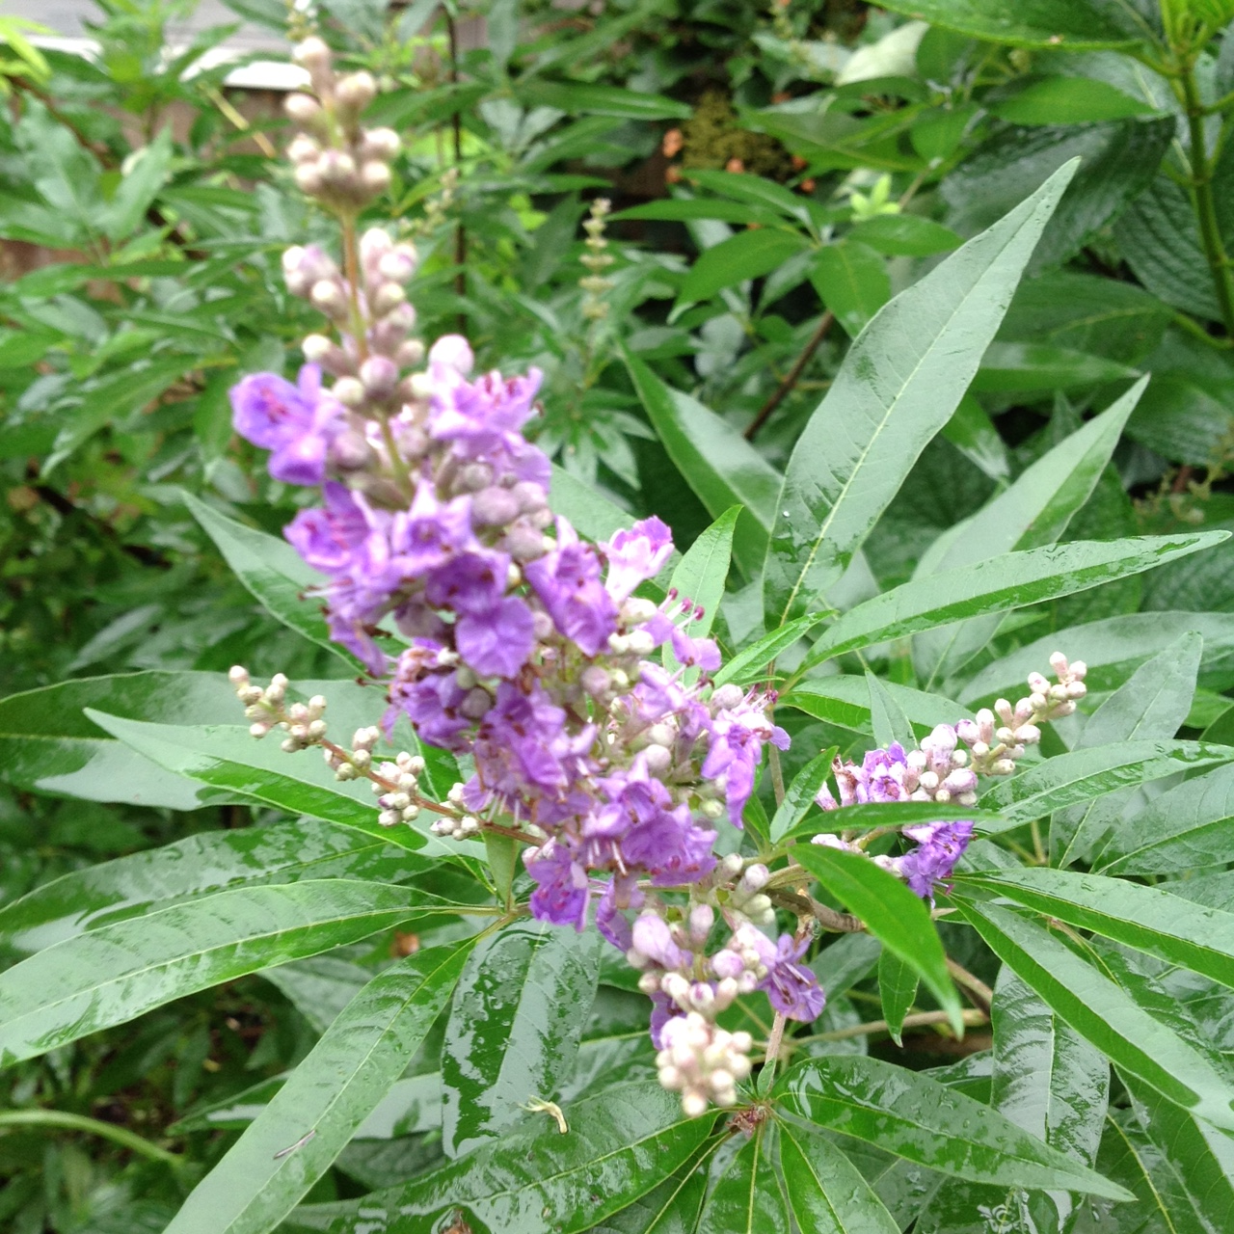

(continued)

The heavy rains of fall set trees and shrubs up for healthy winter roots. But the sudden sharp freeze and the cold drying winds

recently may have freeze dried the buds on colored hydrangeas. The buds were set last fall and must have survived the winter to bloom. They are vulnerable to cold blasts. Keeping the shrubs to 30 inches in height, surrounding them with a wire pen in the fall, and filling the pen with dry leaves level to the top offers some protection. Avoid pruning once the buds form. Control the size of your hydrangeas when you are deadheading, don’t do a major prune in the fall.

A gardening adage is: if a shrub blooms in the spring, don’t prune it in the fall.

Here’s to warm days and being together at meetings!

*If you are on Facebook, be sure to join our page - The Plymouth Garden Club.*

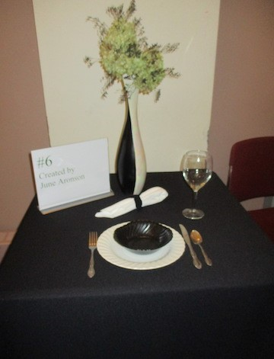

**CONSERVATION TIPS from Joan Bartlett:**

Usually at this time of year, our Garden Club has a visit from Litter Lady with news of the Town wide Spring Cleanup. The town is not able to back up this volunteer project this year because of the pandemic. If any of you are feeling ambitious, though, there’s plenty of trash out there and you are welcome to pick some up, CAREFULLY, to put it in your own orange bags for curbside pick-up or to take to the dump. Be careful, wear gloves and wash afterward. Also, let’s encourage family and friends not to litter.

There are a number of other conservation activities going on in town that can use your attention and advice. Town meeting (virtual) is scheduled for April 3 with a preview on TV on March 25. A number of preservation and open space articles are coming up for a vote. Be in touch with your town meeting representative and go to your precinct meeting to give support.

Then . . . give yourself a little gift by watching a gardening-based movie on NetFlix**: A Little Chaos**. A romantic drama that follows Sabine (Kate Winslet), a strong willed and talented landscape designer who is chosen to build one of the main gardens at Louis XIV’s palace at Versailles. In her new position of power, she challenges gender and class barriers while becoming professionally and romantically entangled with the court’s renowned landscape artist Andre LeNotre.

**LIBRARY BEDS:** Coletta asks that bed tenders please check their beds early this spring and do a general clean up of debris and weeds so they will look nice and be ready for planting additional perennial plants at a later date to be announced.

**PENNIES FOR PINES:** Since thePenny Pineorganization requires donations to be in multiples of $68 our treasurer Rose Cain sent a check of $340 for planting trees due to the widespread devastating wildfires in California and other western states.

**With regrets** the Board accepted the resignation of Rebecca Freer Freedman as Co-President because of family commitments.

**MAYFLOWER: The GCFM magazine** is no longer mailed to member’s homes, but it is available on their website: [GCFM.org](https://www.gcfm.org) The December issue is the latest, but you can also read past issues and find other interesting information and videos on the website. The Groton Garden Club through GCFM has invited garden club members to a free zoom webinar on Saturday, **February 13** at 1:30 pm on the **Natural Control of Invasive Plants** presented by Michael Nadeau. You can register through NRWS or the Groton Garden Club [here](https://us02web.zoom.us/webinar/register/WN_uk7amsg4TcqjyPK2bKV4PQ).

**Landscaping for Bird Diversity**: A zoom presentation with Claudia Thompson, founder of Grow Native. This Program is brought to you by Herring Ponds Watershed Association. **Monday, February 22, 2021** 7:00 PM. **Register** [here](https://zoom.us/meeting/register/tJUtdOCoqTktH9Hb60tS_jdr6DKVIGq1K-SI).

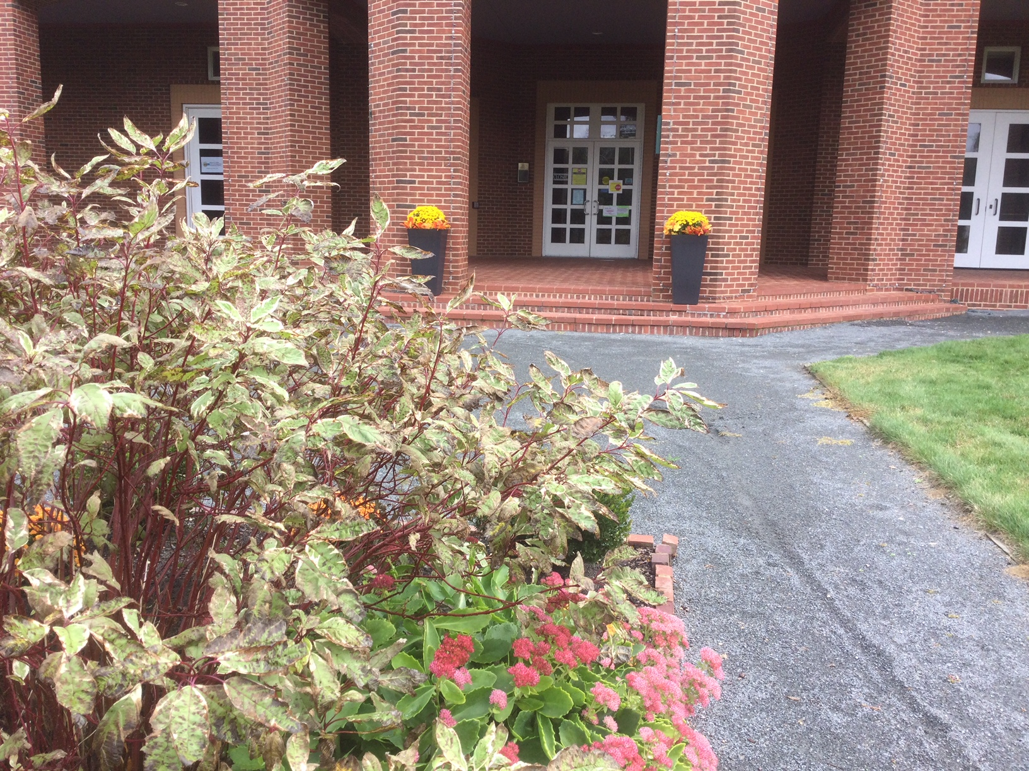

***Building Community through***

***Gardening Together***

Treasury report as of 1/1/21: Checkbook: $16288.97 Scholarship fund: $10,729.70